**THE**

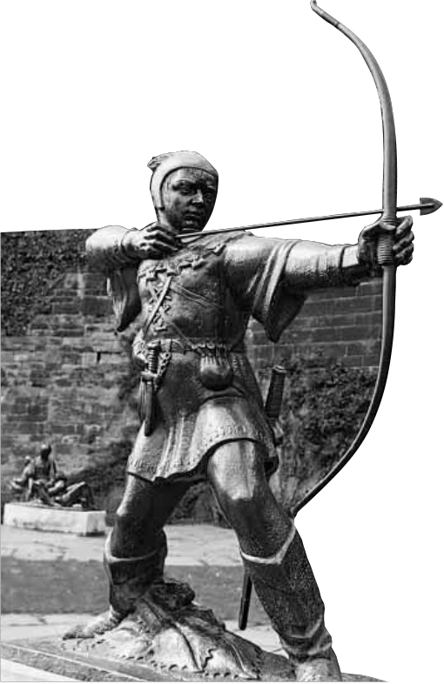

*N*

*ews*Letter

**No. 161 The University of Nottingham October 31 1997**

**Page three Page five Campus Arts**

●**Slashing** ●**Department merger** ●

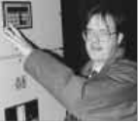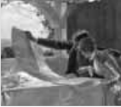

**In pursuit**

**the energy bills across**

**campus**

**will help meet the needs of the construction industry for the 21st-century**

**of leisure ... Victorians at play**

**Robin makes it to the Big Apple**

O

**Photograph provided by Nottingham City Council**

ne of the world’s most enduring legends came under the spotlight at an

nternational conference this month, s a Nottingham academic joined

elegates from all over the world to iscuss a centuries-old folk tale.

Outlaw and all-round good guy Robin Hood was the focus for the rst ever international gathering in

New York of scholars specialising in spects of the legend—they

ncluded Helen Philips from the University’s Department of English

tudies who spoke on the role of ames in the Robin Hood texts.

There are already plans for a econd International Robin Hood

Conference to be held in Nottingham at the University in

999.

“Afeature of Robin Hood material is the range of forms in which the legend is told: plays may

ave been the earliest medium for

he stories in the Middle Ages; there are also ballads, broadside printed

editions, children’s literature, TV and film, pantomimes, cartoons, novels

and poetry—Keats wrote on Robin Hood as a radical. The hero has also inspired all sorts of popular sayings, from ancient proverbs to modern newspaper headlines and adverts, especially in Nottinghamshire,” said Helen Phillips.

“Itis the development of academic interest in popular culture, popular and protest literature, film studies and also in non-standard and non- authoritative genres, that has made this long-lived legend of interest to researchers in many areas. The conference included films, music, performance and an exhibition of art with Robin Hood as a theme.”

Ms Phillips’ particular area of interest in the legend is the place names which occur in ballads and the paper she presented focused on:

*Outlaws and Forests, Places and Plots:*

*The Role of Names in the Robin Hood Texts*.

***(Continued on page two ...)***

**News**◆ **Research Focus**◆ **Across The Quadrangle**◆ **Campus Arts**◆ **Student View**

1