

**Tap to Get Started with Keynote.**

Scroll through the slides. Touch the images and text. And experience the most powerful presentation app ever designed for a mobile device.

**Part 1: Get to Know Keynote**

Explore the toolbar.

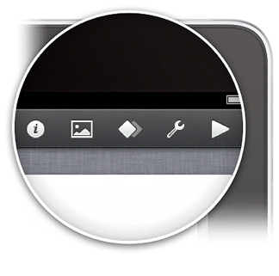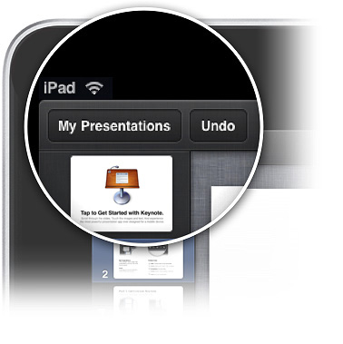

**My Presentations**

Create new presentations and ﬁnd the ones youʼve worked on before.



Your progress is saved automatically as you work.

**Undo**

Anything you do can be undone with just one tap. Touch and hold to redo.

**Toolbar buttons**

**Info:** Change object or text properties. **Insert:** Add a photo, table, chart, or shape. **Animation:** Animate slides.

**Tools:** Search, check spelling, and more. **Play:** Play your presentation.

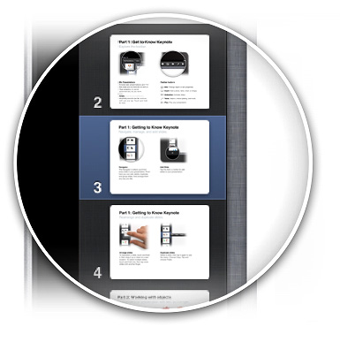

**Part 1: Get to Know Keynote**

Navigate, manage, and add slides.

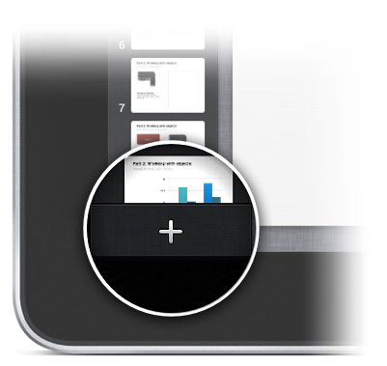

**Navigator**

The Navigator is where youʼll find every slide in your presentation. From here you can add, delete, duplicate, and group slides. And arrange them any way you like.

**Add Slide**

Tap the Add (+) button to add slides to your presentation.

**Part 1: Get to Know Keynote**

Rearrange and duplicate slides.

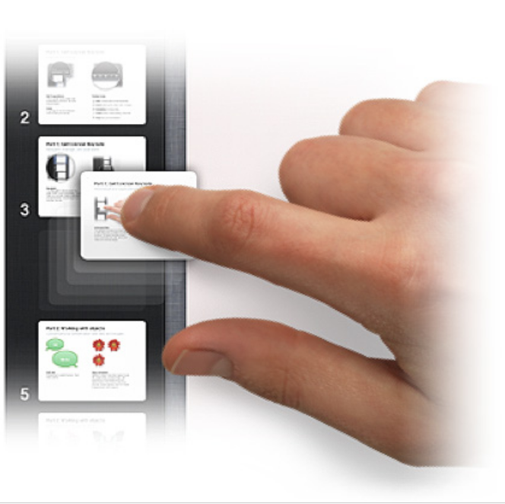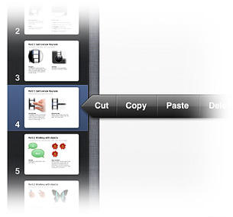

**Arrange slides**

To reposition a slide, touch and hold it, then drag it up or down to a new location. To select multiple slides, touch and hold one, then tap more slides with another ﬁnger.

**Duplicate slides**

Select a slide, then tap it again to see the menu. Choose Copy. Tap and choose Paste.

**Part 2: Working with Objects**

Customize your presentation with text and images.



**Hi**



**Hello**



**Edit text**

Double-tap to select the text. Then begin typing.

**Copy and paste**

Select an object, then tap it again to see the Copy button. Choose Copy. Tap anywhere on the background, and choose Paste. Then move the new object wherever you like. Guides appear when the object is aligned with other objects.



**Part 2: Working with Objects**

Manipulate objects on the slide.



**Move, scale, and rotate**

Touch and hold the object, then drag it to a new position. To resize it, drag the selection handles. To rotate, touch and hold the object with two

ﬁngers, then turn.

**Try it yourself**

Touch and hold the butterﬂy. Move it around. Change the angle. And make it bigger or smaller.

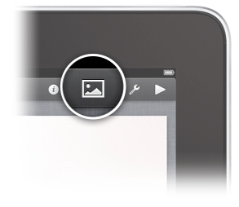

**Part 2: Working with Objects**

Add text or objects.

**Add objects to this slide**

Tap the Insert button. Choose shapes, text, charts, tables, or your own photos.

**Part 2: Working with Objects**

Add style to your presentation.

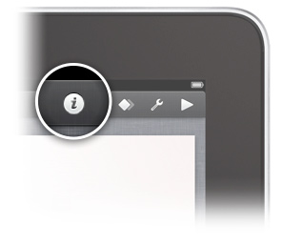

Hello.



**Styling objects**

Select an object to the left. Tap the Info button. Then choose an available style.



**Part 2: Working with Objects**

Visualize data with charts.

50



37.5

25



**Edit the chart**

Double-tap the chart to reveal the Chart Data Editor. From here, you can edit your data using the onscreen keyboard.



12.5

0

2010



**Part 3: Adding Animations**

Itʼs easy to make your work more entertaining.

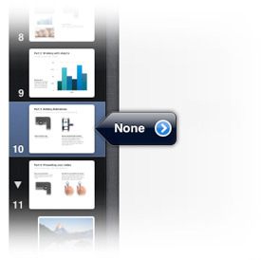

**Enter animation view**

Tap the Animation button.

**Add an animated slide transition**

Tap the transitionsﬂagnext to the slide in the Navigator. In the Transitions window, scroll to browse all transitions. Tap to apply the one you like to the slide. Tap Done to exit animation view.



**Part 4: Presenting Your Slides**

Time to play your new presentation!



**Play your presentation**

Tap the Play button in the toolbar. The presentation will play in full screen.

**Navigate the presentation as it plays**

Tap once or swipe left to advance to the next slide. Swipe right to return to the previous slide. Try it now to see some

of the dramatic transitions in Keynote.



**Twist**



**Cube**



**Reflection**

**Magic Move**



**Magic Move**

Create sophisticated animations using the same objects on two slides. Change the position, size, rotation,



or opacity of the

objects, and Keynote automatically animates them from one slide to the next.

**Object builds**

You can animate any object on your slide using build animations. Tap anywhere on the slide to view examples below.



**Pop Twirl Drop**

**Part 5: Wrapping Up**

The perfect finish for your presentation.

**x 2**



**Exit play mode**

When youʼre ﬁnished presenting, simply double-tap anywhere on the slide.

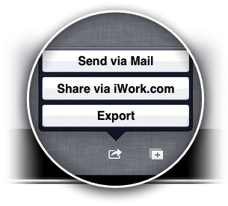

**Part 6: Sharing Your Work on the Web**

iWork.com makes it easy to send your presentation.

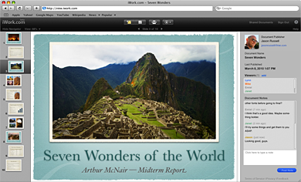

**Share with others, or just yourself**

Tap the My Presentations button in the toolbar to view all your presentations. Select “Share via iWork.com” from the Share menu. Sign in, invite friends or co-workers, then tap the Share button to upload to the web.



With iWork.com, anyone on a Mac or PC can view your presentation and post comments, or download a version in Keynote or PDF format.



**Now try Keynote for yourself.**

Now that you know the basics, start exploring Keynote by creating your own presentation. Or visit http://help.apple.com/keynote/1.0

For additional help, tap the Tools button, then tap“Goto Help.”