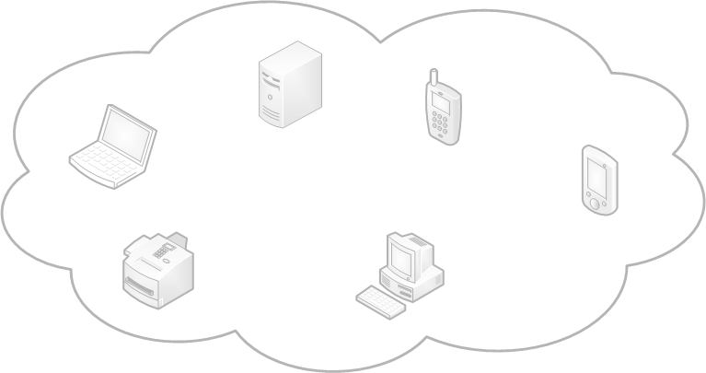

**The *Virtual* OSGi Framework**

**Jan S. Rellermeyer**

“Inaugural Talk”

Invited Researcher of the OSGi Alliance

Systems Group

Department of Computer Science ETH Zurich

8092 Zurich, Switzerland



2008 by Jan S. Rellermeyer, ETH Zurich; made available under the EPL v1.0 | March 19th 2008

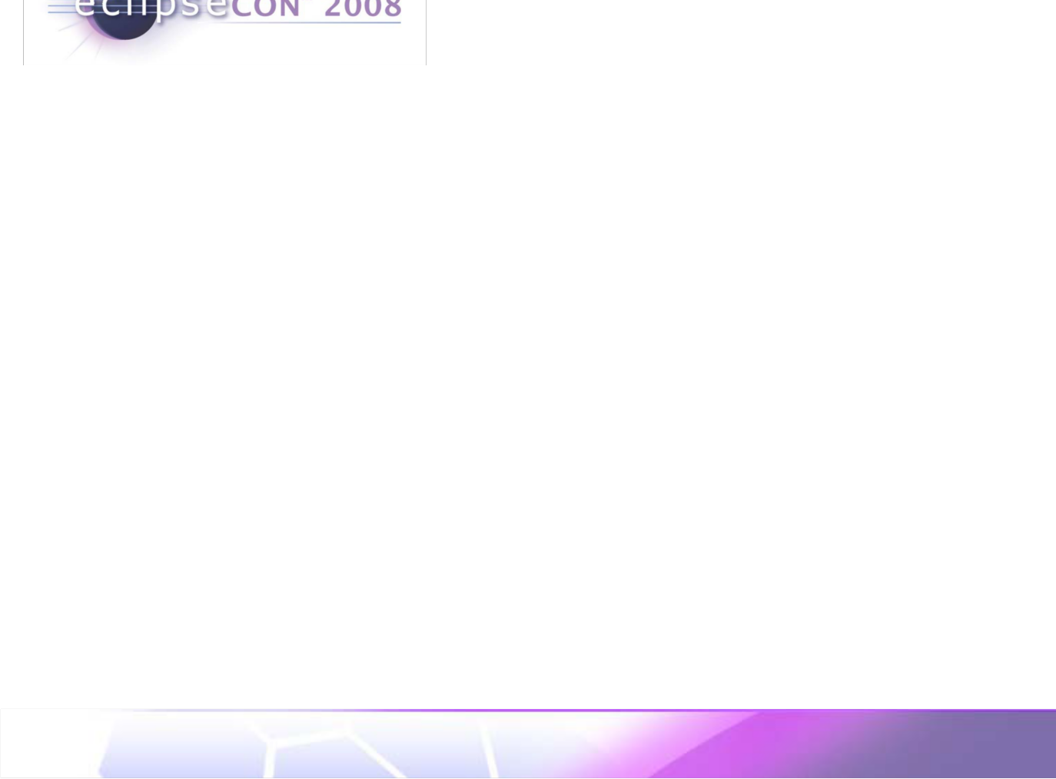

Virtual OSGi? VOSGi?

•Unintended name clash

•VOSGi is work by Stephane Frenot et. al.

•Share services among virtual gateways

More like OS- Virtualization

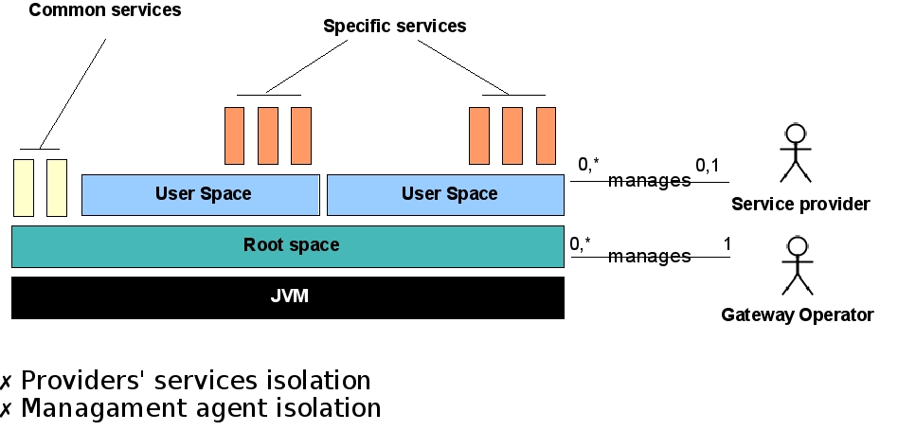

[Y. Royon, S. Frenot: ***Un environnement multi-utilisateurs orienté service***. In: CFSE 2006]

The Virtual OSGi Framework | ©2008 by Jan S. Rellermeyer, ETH Zurich; made available under the EPL v1.0



Remember EclipseCon 2007…

•R-OSGi

•Originally motivated by embedded systems

•Service Discovery via SLP

Services were described by SLP Service URLs

Proxy

Bundle

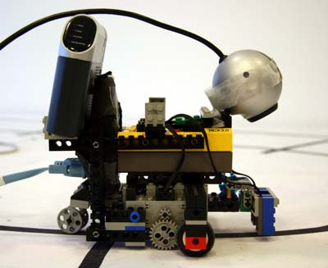

Presentation

EventAdmin

EventAdmin

RobotDevice

RobotDevice

EventHandler



R-OSGi

R-OSGi



[J. S. Rellermeyer, G. Alonso, and T. Roscoe: ***R-OSGi: Distributed Applications Through Software Modularization***. In: Middleware 2007]

The Virtual OSGi Framework | ©2008 by Jan S. Rellermeyer, ETH Zurich; made available under the EPL v1.0



R-OSGi Today

More feasible for

•Point to point

remote services on the

•Explicit connections server side.

•Service Discovery is an optional part

•Closer to OSGi

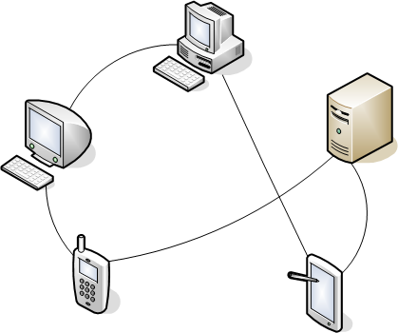

RemoteServiceReferences known

after lease exchange Already synchronizedProxy is generated when the service

is retrieved by a client

Transparently “import”the remote service into the local framework

Gives“hints”where to connect to.

The Virtual OSGi Framework | ©2008 by Jan S. Rellermeyer, ETH Zurich; made available under the EPL v1.0



R-OSGi as an ECF Remote Service Provider

•ECF API on top of R-OSGi

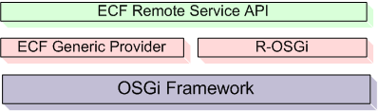

DSO on an ECF server

Transparent, point to point remote services

•Thereby, non-transparent access on top of a transparent service approach

•E.g., asynchronous service invocation

The Virtual OSGi Framework | ©2008 by Jan S. Rellermeyer, ETH Zurich; made available under the EPL v1.0



Motivation: Distributed Service Registry

•Original R-OSGi

Service Discovery

•R-OSGi 1.0.0.RCs

Pair wise joined Service Registry

Still service registry and remote service registry

•ECF Generic Provider

Server and DSOs

“The network is th service registry”

“Remote Service Registry = union o connected servic

registries”

“Centralized servi registry”

•Other possibility: Unified service registry for both local

and remote services

**The Virtual OSG Framework**

The Virtual OSGi Framework | ©2008 by Jan S. Rellermeyer, ETH Zurich; made available under the EPL v1.0



Motivation: Tool for “Orthogonal Distribution”

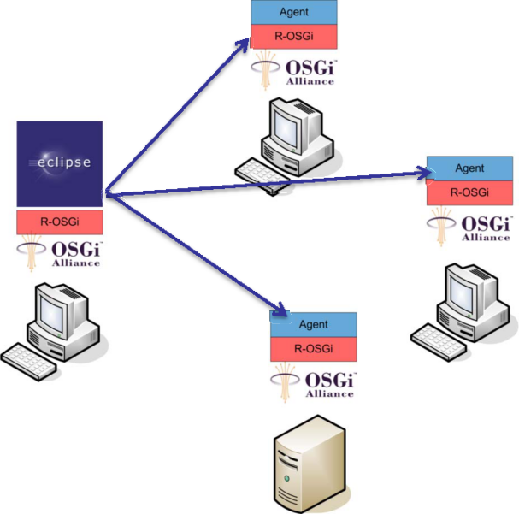

Demo

[Jan S. Rellermeyer, Gustavo Alonso, Timothy Roscoe: ***Building, Deploying, and Monitoring Distributed Applications with Eclipse and R-OSGi****.*In: Eclipse Technology eXchange (ETX) Workshop (in conjunction with OOPSLA 2007)].

The Virtual OSGi Framework | ©2008 by Jan S. Rellermeyer, ETH Zurich; made available under the EPL v1.0



How does it work?



Proxy Bundle Channel

Endpoint



Service

Channel Multiplexer

Channel Endpoint

Channel Endpoint

The Virtual OSGi Framework | ©2008 by Jan S. Rellermeyer, ETH Zurich; made available under the EPL v1.0



The Problem of State

•Failover

•Load balancing

•Real Services are not always stateless.

Think of the web

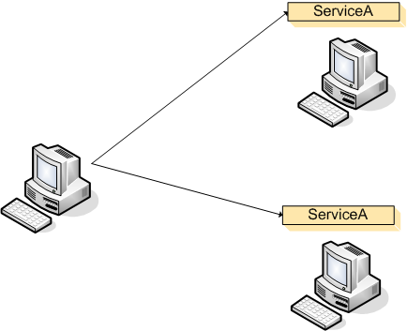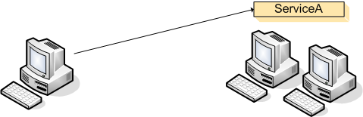

•Couldn’t state be preserved?

•Service replicas instead of just copies?

Task for the middleware

**The Virtual OSGi Framework**

The Virtual OSGi Framework | ©2008 by Jan S. Rellermeyer, ETH Zurich; made available under the EPL v1.0



Motivation: Sensor Nodes as OSGi Services

[with Michael Duller]

•TMote Sky

TI MSP430F1611 microcontroller at up to 8 MHz10k SRAM, 48k Flash + 1024k serial storage

250kbps 2.4 GHz Chipcon CC2420 IEEE 802.15.4 Wireless Transceiver

•Cannot even run an OS

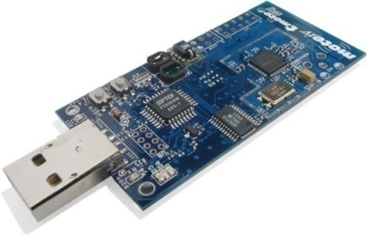

Runs TinyOS

•But it can be an R-OSGi service…

Demo

[J.S. Rellermeyer, M. Duller, and G. Alonso. ***Using Non-Java OSGi Services for Mobile Applications***. Demo at: MiNEMA 2008 Workshop in conjunction with EuroSys 2008].

The Virtual OSGi Framework | ©2008 by Jan S. Rellermeyer, ETH Zurich; made available under the EPL v1.0



Extending the Idea of OSGi Services

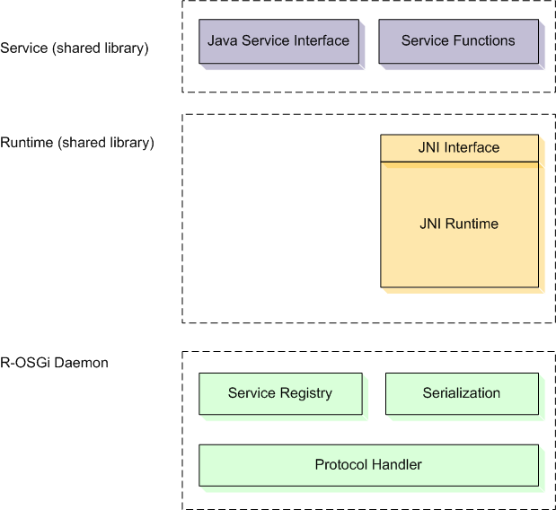

Why should a remote OSGi service have to be written in Java?

•C/C++

•CLDC

•Over Bluetooth,…

Would be nice to have this for local services as well

**The Virtual OSGi Framework**

[J.S. Rellermeyer, M. Duller, K. Gilmer, D. Maragkos, D. Papageorgiou, and G. Alonso: ***The Software Fabric for the Internet of Things***. In: Internet of Things 2008].

The Virtual OSGi Framework | ©2008 by Jan S. Rellermeyer, ETH Zurich; made available under the EPL v1.0



What about consuming services

•The consumer has to be an OSGi framework

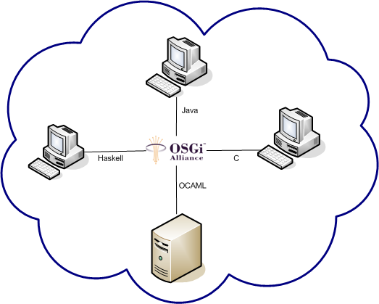

•But,…

•Couldn’t it be

**The Virtual OSGi Framework**

The Virtual OSGi Framework | ©2008 by Jan S. Rellermeyer, ETH Zurich; made available under the EPL v1.0



The Virtual OSGi Framework

•OSGi on the cloud

Have a network full of machines running OSGi

Don’t care where they are

Don’t care where bundles are installedDon’t care where services are providedAccess them from anywhere

**Bundles and service are becoming virtua**

**Access them transparently**

•Fluid OSGi

Have a replica where you need itRead any / write any

**From a peer’s perspective, servic**

**“flow”through th network**

The Virtual OSGi Framework | ©2008 by Jan S. Rellermeyer, ETH Zurich; made available under the EPL v1.0



Architecture

•Unifying local and remote services

•As an extension, non-invasive against the framework

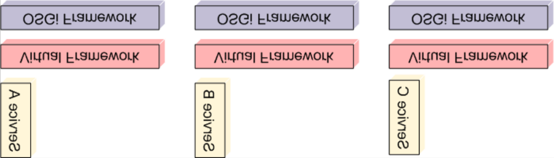

The Virtual OSGi Framework | ©2008 by Jan S. Rellermeyer, ETH Zurich; made available under the EPL v1.0



Architecture

•Unifying local and remote services

•As an extension, non-invasive against the framework

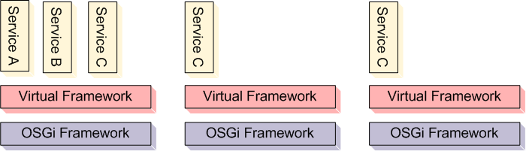

**Equivalent for a peer**

**on the cloud**

The Virtual OSGi Framework | ©2008 by Jan S. Rellermeyer, ETH Zurich; made available under the EPL v1.0



Virtualized Module Layer

•The Virtual Framework runs as a bundle on the host framework

•Virtual Bundles are installed on the host framework

•Virtual Bundles are started on the virtual Framework

[Dimitrios Papageorgiou]

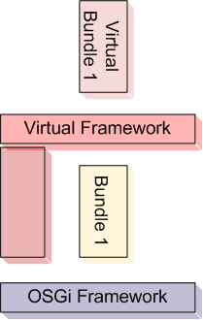

**Host framework**

The Virtual OSGi Framework | ©2008 by Jan S. Rellermeyer, ETH Zurich; made available under the EPL v1.0



Virtual Bundles

•Installation of the bundle

• Install on the host framework

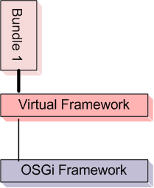

• Pass back a VirtualBundle instead of the host framework’s Bundle implementation

•Starting the bundle

• Called through a VirtualBundle

• get the Activator from the host framework

• Call it with a VirtualBundleContext

• Handle the virtual state of the bundle within the virtual framework

• Subtile: ensure BundleID consistency

The Virtual OSGi Framework | ©2008 by Jan S. Rellermeyer, ETH Zurich; made available under the EPL v1.0



Distributed Registries

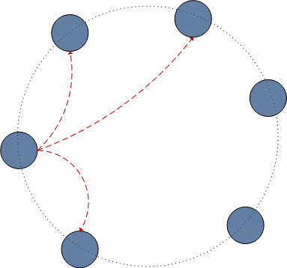

•Centralized registries are replaced by a distributed registry

•Prototype system: kind of DHT

Can store pointers to bundles

Supports constraints

Can store pointers to services + attributes

Supports filters

The Virtual OSGi Framework | ©2008 by Jan S. Rellermeyer, ETH Zurich; made available under the EPL v1.0



Challenges

•Mapping the class space model to the DHT

Optimization for resolving

•getAllServices becomes a very expensive

operation

Is there a good Tradeoff?

•Maintaining replicas of DHT nodes

•Scalability?

Can it scale to massively distributed systems?Can it scale to the diameter of the internet?

Transactional m

Currently not ou focus!

The Virtual OSGi Framework | ©2008 by Jan S. Rellermeyer, ETH Zurich; made available under the EPL v1.0



OceanStore?

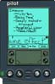

[J. Kubiatowicz, D. Bindel, Y. Chen, S. Czerwinski, P. Eaton, D. Geels, R. Gummadi, S. Rhea, H. Weatherspoon, W. Weimer, C. Wells, and B. Zhao: ***OceanStore: An Architecture for Global-Scale Persistent Storage***. In: ASPLOS 2000]

The Virtual OSGi Framework | ©2008 by Jan S. Rellermeyer, ETH Zurich; made available under the EPL v1.0



Service Replication [Damianos Maragkos]

•Fluid Replication

Place a replica of the service where ever it is needed

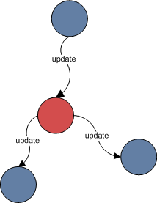

•Preserve the state between service replicas

•Prototype: Communication model through the DHT

•Coordinator nodes

For update propagation

For using different consistency levels within the same virtual framework

The Virtual OSGi Framework | ©2008 by Jan S. Rellermeyer, ETH Zurich; made available under the EPL v1.0



PRACTI?

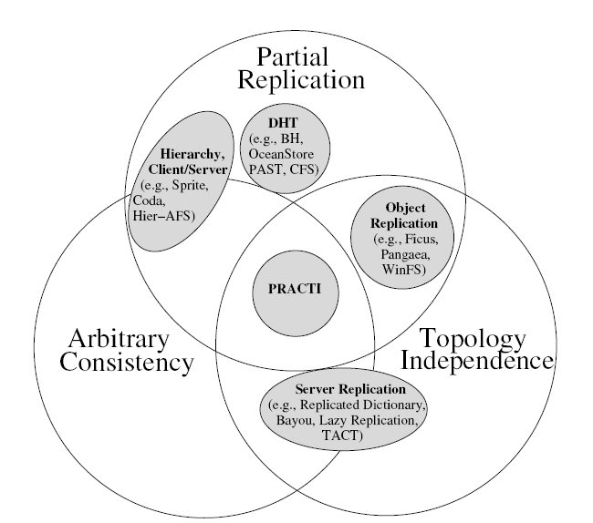

•Partial Replication

•Arbitrary Consistency

•Topology Independence

[N. Belaramani, M. Dahlin, L. Gao, A. Nayate, A. Venkataramani, P. Yalagandula, and J. Zheng: ***PRACTI Replication***. In: NSDI 2006]

The Virtual OSGi Framework | ©2008 by Jan S. Rellermeyer, ETH Zurich; made available under the EPL v1.0



Replication of Services

•What is state?

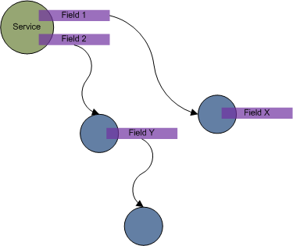

Model: Only services have stateState is contained in fields

•Capturing state?

Update propagationArbitrary consistency

•Goal: Transparent replication

Run with every OSGi ServiceRequires no changes

The Virtual OSGi Framework | ©2008 by Jan S. Rellermeyer, ETH Zurich; made available under the EPL v1.0



OpenTerracotta?

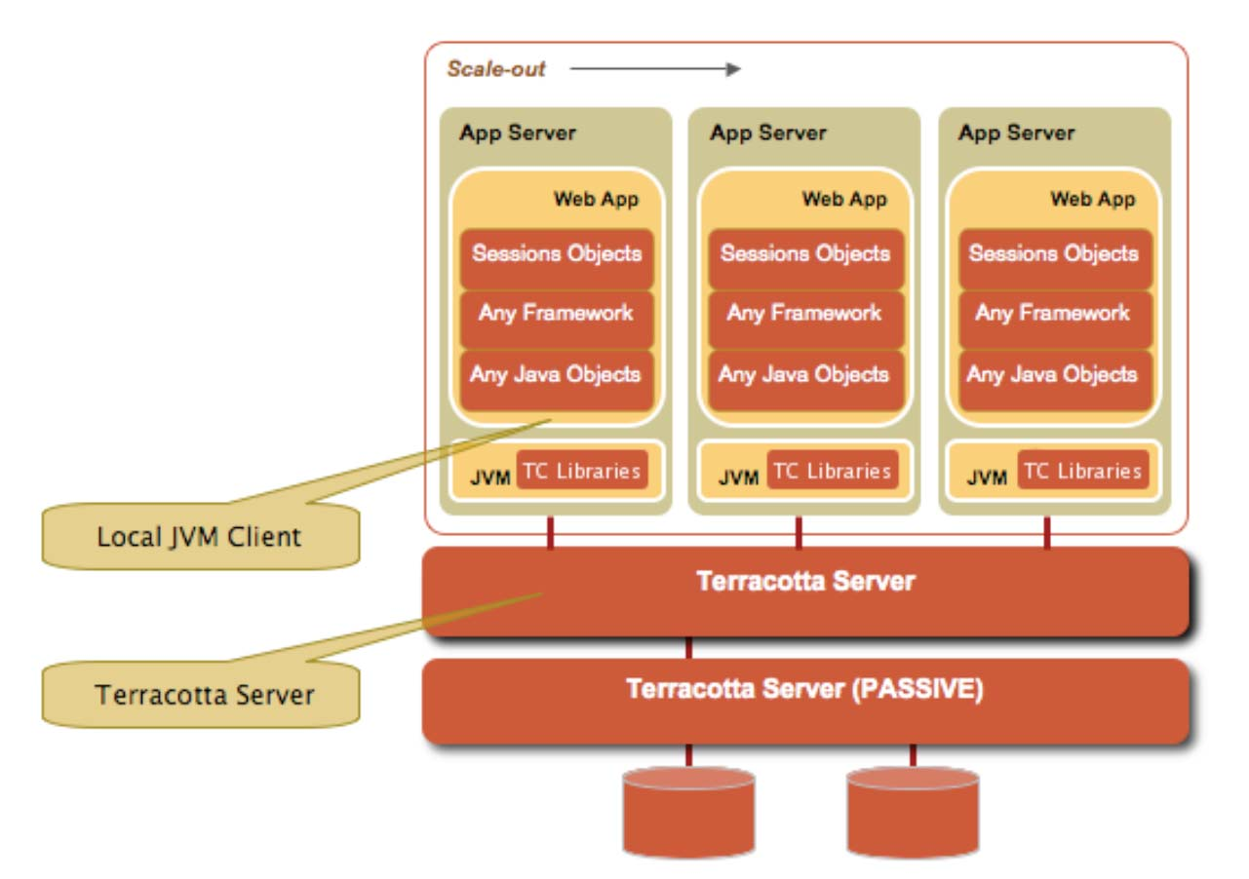

•Transparent clustering

•Load time instrumentation

•Distributed locking

[http://www.terracotta.org]

The Virtual OSGi Framework | ©2008 by Jan S. Rellermeyer, ETH Zurich; made available under the EPL v1.0



Instrumentation

•Symbolic Execution

Find out where state accessed/changed

•Instrumentation to capture fields

P2P update propagat through group communication

•Also does distributed locking, distributed thread

coordination

•Also used for service migration

But we also handle thread migration.

Seamless parallelizat

Can be considered a temporal replicatio

The Virtual OSGi Framework | ©2008 by Jan S. Rellermeyer, ETH Zurich; made available under the EPL v1.0



What we have now…

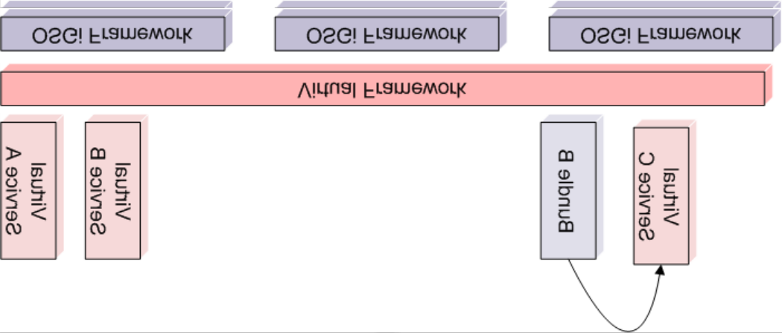

The Virtual OSGi Framework | ©2008 by Jan S. Rellermeyer, ETH Zurich; made available under the EPL v1.0



Coordination overhead

Duality between Service Replicas

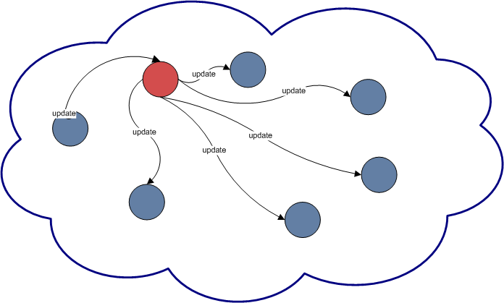

Remote Services

•Coordinating all the replicas

•Affects scalability

The Virtual OSGi Framework | ©2008 by Jan S. Rellermeyer, ETH Zurich; made available under the EPL v1.0



Outlook: Autonomous Controller

[Ramon Küpfer, Dario Simone; starting soon]

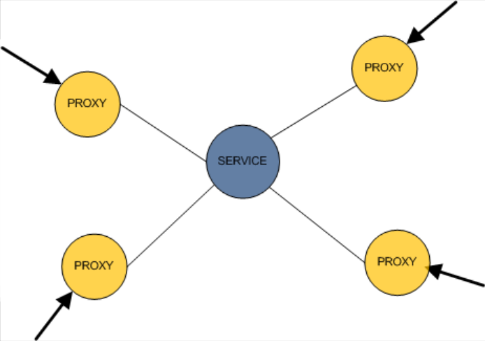

The Virtual OSGi Framework | ©2008 by Jan S. Rellermeyer, ETH Zurich; made available under the EPL v1.0



Outlook: Language-independent OSGi

•Soon a prototype for Barrelfish (new operating system

at ETH) [withAndrewSimonBaumann,Peter,TimothyAdrian Schüpbach,Roscoe]

Use the kernel-provided IPC modelProvide an application model

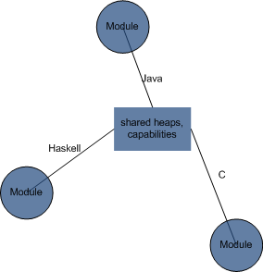

(derived from OSGi)

Optimize for interactions within the same language

Provide generic type mappings for heterogeneous apps

The Virtual OSGi Framework | ©2008 by Jan S. Rellermeyer, ETH Zurich; made available under the EPL v1.0



Conclusions

•The Virtual OSGi Framework

Unifies local and remote services

Makes a (dynamic) group of machines appear as a single OSGi framework

Allows replication of services for load balancing or to increase failure resilience

Runs as a bundle on top of every framework

Uses the host framework for module layer operationsIntercepts/extends certain operations on the

virtualization layer

Can relocate bundles/servicesOSGi on the cluster/cloud

The Virtual OSGi Framework | ©2008 by Jan S. Rellermeyer, ETH Zurich; made available under the EPL v1.0



Welcome to the virtual world!

•Questions?

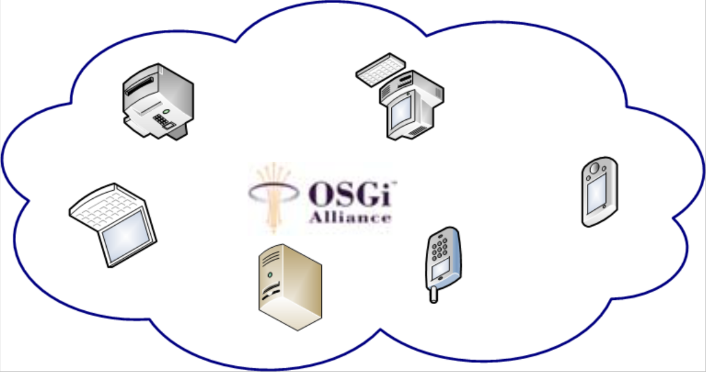

The Virtual OSGi Framework | ©2008 by Jan S. Rellermeyer, ETH Zurich; made available under the EPL v1.0