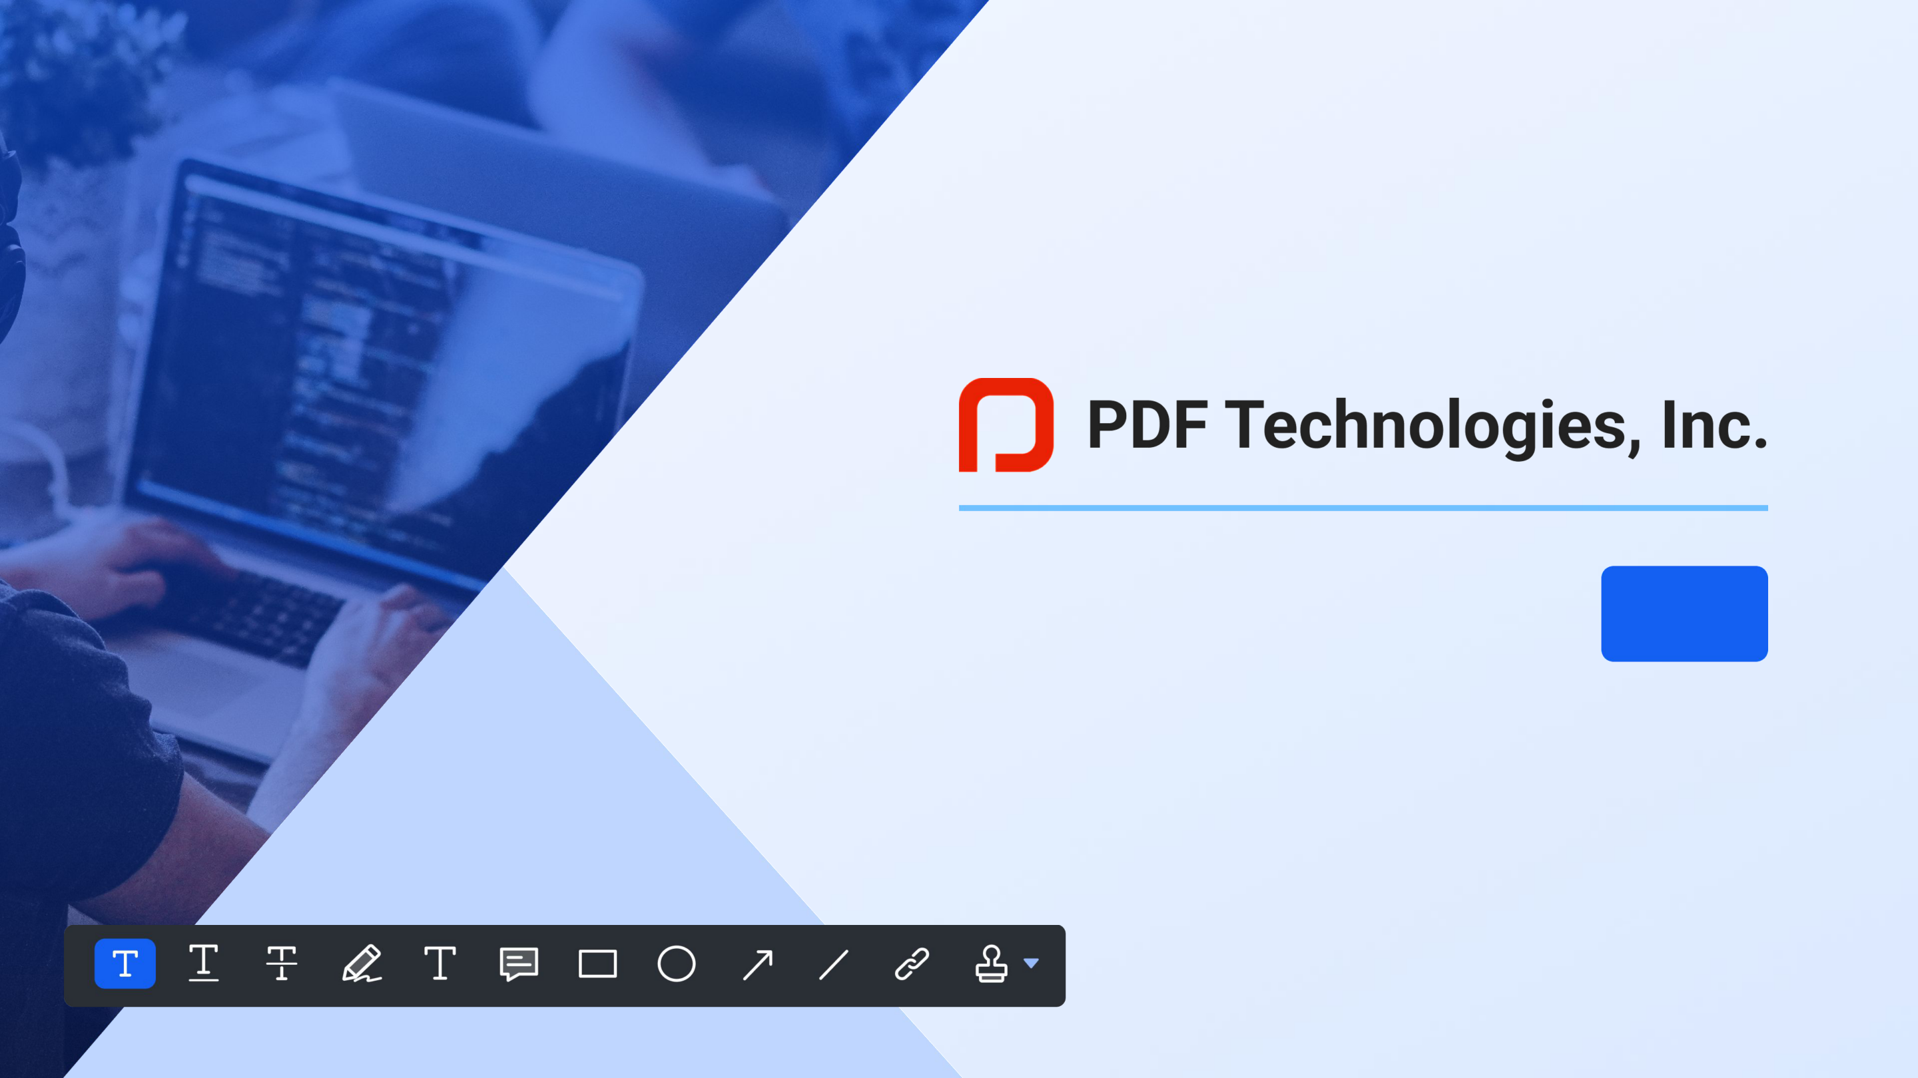

**ComPDFKit SDK**



**Catalogue**

**Company**

Introduction

Snapshots **Products**

**Why ComPDFKit?**



PDF Technologies, Inc. is a company that was founded in 2014 and

has focused on **PDF, format conversion, and video &**

**audio technology**

**PDF Reader Pro series and Filmage series**, the

cross-platform products we developed independently, are beloved by **millions of people** around 167 countries and regions

With years of experience, our team closely follows development and market trends and consistently brings our users the most advanced features. We try to provide the best service and tech support to satisfy customers' development needs



**Snapshots for Products Supported**

**by PDF Technologies, Inc.**

**200M +**

Downloads Worldwide

**10M +**

Users

**40,000 +**

Business & Education Organization

**167**

Countries & Regions



**Catalogue**

**Company**

**Products**

ComPDFKit PDF SDK

ComPDFKit Conversion SDK

**Why ComPDFKit?**

**Products**



**ComPDFKit**



**ComPDFKit**

**PDF SDK**

**ComPDFKit**

**Conversion SDK**



Consist of ComPDFKit PDF SDK and ComPDFKit Conversion SDK

**Help prevent manpower waste, save time and expenses, and concentrate on building great products**

**ComPDFKit PDF SDK**

**All Platforms Supported**



**Mac** Objective-C, Swift, C++, C **iOS** Objective-C, Swift, C++, C **Web** JavaScript

**Windows** C# WPF, C# UWP, C++ **Android** Java, Kotlin **Server(Windows & Linux)** C++

**ComPDFKit PDF SDK**

**Advanced Capabilities**



**Viewer**

Provide a strong rendering

engine with a wide range of advanced features, including single- and double-page layouts, continuous scrolling, and intuitive document navigation via scrolling, bookmark, outline, and thumbnail

**Annotations**

Enable users to add, edit, import, and export all types of PDF markings, including a variety of annotation tools such as highlights, notes, shapes, and ink drawing

**Forms**

Create, edit, ﬂatten, and print form ﬁelds with ease. All form types are supported, such as text boxes, checkboxes, radio buttons, drop-down lists, pushbuttons, and signatures

**Document Editor**

Quickly organize and manage PDF ﬁles, including page creation, rearranging, rotation, cropping, extraction, document merging, and deletion

**ComPDFKit PDF SDK**

**Advanced Capabilities**



**Security**

Use encryption method, user

password, owner password, or setting permission, redaction to remove sensitive information, watermark to avoid counterfeiting and more

**Edit PDF**

Eﬀortlessly add, edit, delete text and images in PDF ﬁles, supporting the change of the size, font, and color of document content

**Signatures**

Add drawn, scanned, or written signatures to PDF documents or digitally sign the documents for integrity and authenticity protection



**ComPDFKit PDF SDK**

**Suitable for Every Occasion**



**Construction**

Archive paper artworks and

materials in PDF, and allow

staﬀ members to annotate and edit these PDF ﬁles to work together on projects quickly

**Education**

The PDF has been widely used in education industry, as the editing function enables users to quickly modify courseware, and underline, highlight,

shapes, etc. are used to annotate theses to assist learning

**Government**

Provide public sectors with reliable document viewer and security protector like redaction that can permanently black out sensitive information in PDF

ﬁles, including social security accounts, credit card numbers, addresses, and more

**Finance**

Through the convenient data extraction function, the target data in professional reports such as research reports,

ﬁnancial reports, and prospectuses can be quickly extracted and combined