Welcome to Adobe Acrobat

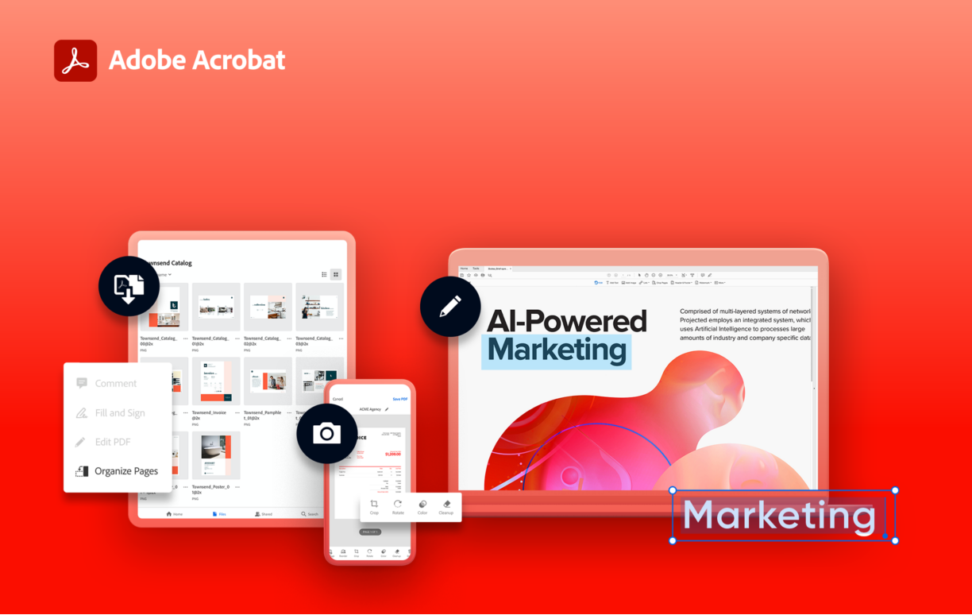

Here are 3 tips for a simpler way to work.

01 | **Edit and e-sign PDFs, all in one tool**

Simplify the way you work and communicate through documents. Do it all—even collect e-signatures—with just one tool.

**Edit anything.** Convert digital or paper docs to editable, searchable PDFs. **Fill and e-sign.** Digitally fill out and sign any document.

**Collect e-signatures.** Quickly gather e-signatures and forms from anyone. No separate e-sign tool needed.

Acrobat Pro subscribers can also use enhanced e-signature features to create web forms, add custom branding, send for e-signatures in bulk, and collect payments, where applicable.

02 | **Work from anywhere**

Desktop, web, or mobile—it’s up to you. Access your documents and easy-to-use PDF and e-signature tools from any device.



Use Acrobat tools within the apps you already use daily. Acrobat integrates seamlessly with **Dropbox, Box, Google Drive, Google Chrome, Microsoft 365**, and more.

03 | **Share files with others**

Share files for viewing, commenting, or signing—across desktop, web, and mobile.

**Share files fast.** Click, add, and send. It’s that easy. And recipients can view on any device with no software required.

**Collaborate with ease.** Send one email with one link to multiple reviewers. Access full collaboration tools that work with your PDFs so you can easily leave comments, add @mentions, highlight, or search a document.

**Manage your files.** You’re in control. Get real-time updates when comments have been added. You can even send reminders and add deadlines.

**Get help from Adobe**

Take advantage of tutorials and forums—and share your feedback with the Adobe Acrobat team. **Get tutorials.** Become an expert with short videos and online instruction.

**Visit Adobe forums.** Ask questions and find answers in Adobe Acrobat forums.

**Share your feedback.** We need your help to continue to make Acrobat the best solution available. Please share your thoughts.